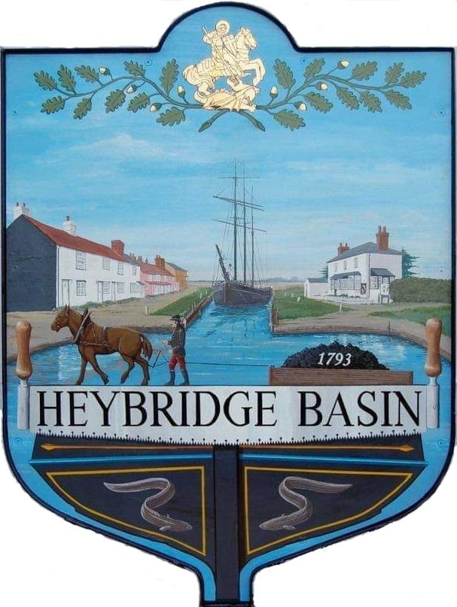

HEYBRIDGE BASIN PARISH COUNCIL

Minutes of the Full Council meeting of Heybridge Basin Parish Council held on Tuesday 11th February 2025 at 06:30pm, at St George’s Community Room.

PRESENT

In the Chair: M. Hodges (Chair) Absent: 0

Councillors: R. Bryson (Vice Chair) Apologies: 1
C. Edmond
M. Hobden District Cllrs: 2
C. Swann
Public: 1

Officers: G. Lake – Clerk

It was noted that this meeting was being recorded by the Clerk.

24/163 Chair’s Welcome.
The Chair welcomed everyone to the meeting and noted that a Casual Vacancy had arisen due to the resignation of Cllr Howat. The Chair expressed thanks to Cllr Howat for his work with the Council, particularly in planning matters and the Village Design Statement (VDS).

The Chair reported that the '20’s Plenty' bin stickers had been distributed to Basin Road residents.

Additionally, the Chair announced that he would not be accepting nominations for the Chair role for 2025/26 in May and was announcing this in advance so that members could consider whether they wished to put themselves forward.

Finally, the Chair noted that Item 17 would be deferred to the next meeting to ensure all members were present, and that Item 14 would be discussed before Item 12.

24/164 To note apologies for absence.
Cllr Sjollema

24/165 To receive Declarations of Interest in accordance with the Council’s Code of Conduct and with section 106 of the Local Government Finance Act 1992.
Cllr Edmond – Non-Pecuniary – Essex Waterways; Cllr Swann – Non-Pecuniary – Daisy Meadow Car Park and Cllr Hobden – Non-Pecuniary – Basin Oars, Rivercare Group and Heybridge Basin Sailing Association

24/166 To sign as a correct record the minutes of the full council meeting held on 14th January 2025.
The Minutes as previously circulated were agreed and signed as a correct record.

24/167 To receive a report from:
- District Councillors – Cllr Spenceley provided a verbal report.
- County Councillor – No report was received from Cllr Durham.
- Clerk
- Lloyds Bank – The Clerk reported that the application for a new reserves bank account is in progress. Once mandates are signed and IDs submitted, the account may take up to six weeks to open. A savings account can then be added.
- February Half Term - The Clerk will be away from 17th to 21st February, responding only to urgent matters and audit preparations.
- Interim Audit – Scheduled for 25th February.

24/168 Finance.
- To approve
- Payment requests for January/February 2025 were approved.
- Receipts for December January/February 2025 were approved.
- Accounts for the nine months to 31st December were approved.

24/169 Public Forum
No members of public wished to speak.

24/170 Policies/Committees
  - To review the Risk Assessment and agree any action to be taken.
The Risk Assessment was approved.
  - To review the Action Plan and agree any action to be taken.
The Action Plan was approved.
  - To review the draft Homeworking Policy and consider formally adopting.
The Homeworking Policy was approved. Clerk to look into a COSH file and arrange for the electrical equipment to be PAT Tested.
  - To appoint at least 1 additional member to serve on the Personnel Committee.
Cllr Edmond was appointed.

24/171 Office Equipment
  - To consider the quotes for office equipment for the Clerk and agree any action to be taken.
The Clerk was authorised to order a lockable filing cabinet and laser printer at a total cost of £419.00.

24/172 Consultations
- To discuss the SLCC Consultation on strengthening the standards and conduct framework for local authorities in England and agree any action to be taken.
It was resolved that Councillors who wish to respond, do so individually as well as the Clerk.
- To discuss the Essex Air Quality Strategy Consultation and agree any action to be taken.
It was resolved that Councillors who wish to respond, do so individually and for the Clerk to share on social media.

24/173 Planning
- To consider any planning applications received after the publication of the agenda and to agree the action to be taken.
There were no planning applications.

24/174 Dog Fouling
  - To receive an update from the Clerk and agree any action to be taken.
The Clerk reported residents' concerns regarding increased dog fouling. Cllr Swann offered to donate two dog waste bins. It was resolved for members to patrol the village to assess affected areas and discuss solutions at the next meeting.

24/175 Daisy Meadow Car Park (DMCP)
  - To receive an update from the Working Group and agree any action to be taken on the following:
- Electric Vehicle Chargers
Planning permission is not required under Part 2 of the Permitted Development Order. It was resolved to not proceed with this project at this time.
- Daisy Meadow Garden
It was reported that the Scottish Beach Pebbles and large boulders had been delivered. It was resolved to contract HRS Marine services to re-route the water supply at a total cost of £1,100.00 including materials. Cllr Swann abstained from voting.
- Grounds Maintenance Schedule
Clerk advised that the contract expires end of May 2026. Due to work in the car park, the Working Group reviewed the schedule. The amended schedule was approved.
- Public Toilets
Clerk advised that the early engagement advert was on the government tender site, closing on 12th February.
It was resolved that:
- The facilities be free of charge
- The design will include two cubicles, both with disabled access and baby changing facilities, and be time lockable.
- The location will be near the canal steps, requiring relocation of litter bins.
- The Working Group will meet with Essex Waterways
- The Clerk will arrange online meetings with interested contractors.
- The Clerk will contact Maldon District Council regarding Planning Permission.
- Cllr Bryson to continue liaising with the Bentalls Centre Facilities manager.

24/176 VE Day 2025
  - To receive an update from the Working Group and agree any action to be taken.
The Clerk previously circulated a report outlining tasks to be completed and addressing questions related to the event. Tasks were delegated to members of the Council and the Clerk. The Clerk will update the notes and recirculate them. It was resolved to:
- Donate £50.00 to the Regatta Committee for the use of their equipment.
- Order 32 bookmarks at a cost of £44.80
- Order a tub of Haribo and Chocolate coins at a total cost of £31.00
- Allocate a budget of £150.00 for a singer.
- Book Air Raid Jive to perform. Payment in the form of parking and fuel reimbursement.

Both District Councillors left the meeting.
The member of public left the meeting.

It was resolved to continue the meeting until all items were discussed.

24/177 Correspondence
- To note correspondence received and agree any actions to be taken.
Correspondence was noted and responses were agreed.
It was resolved to donate £30.00 to Mrs Edwards for the Broomfield Hospital Intensive Care Unit.

There being no further business the meeting closed at 08:33pm
Provisional Date of the next Council Meeting Tuesday 18th March 2025

Clerk Contact details: clerk@heybridgebasinpc.org.uk
Website: www.heybridgebasin-pc.gov.uk

